118.6+j244

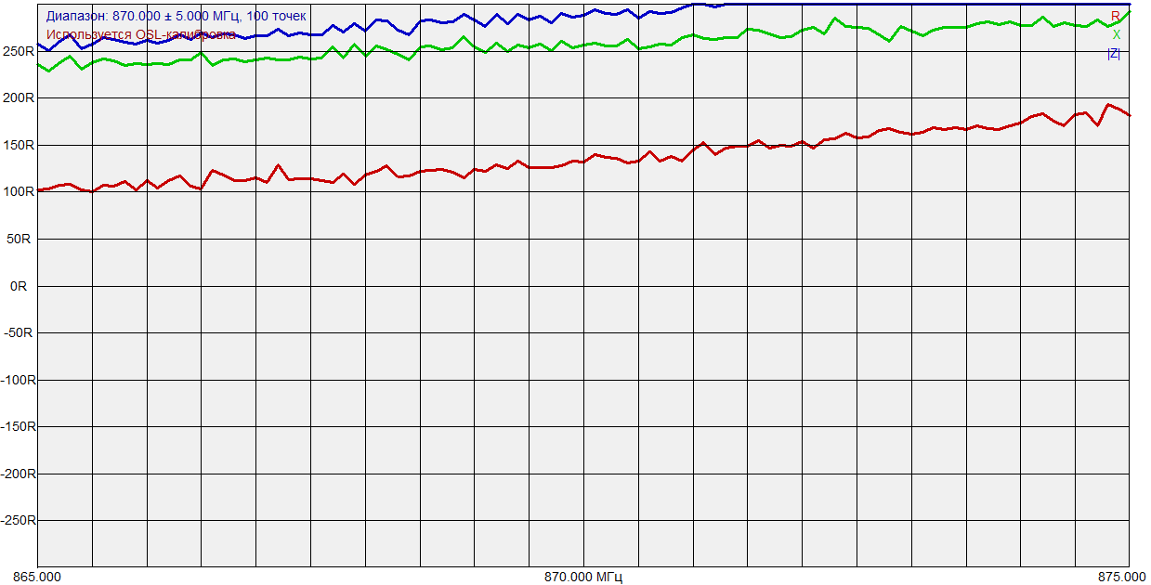

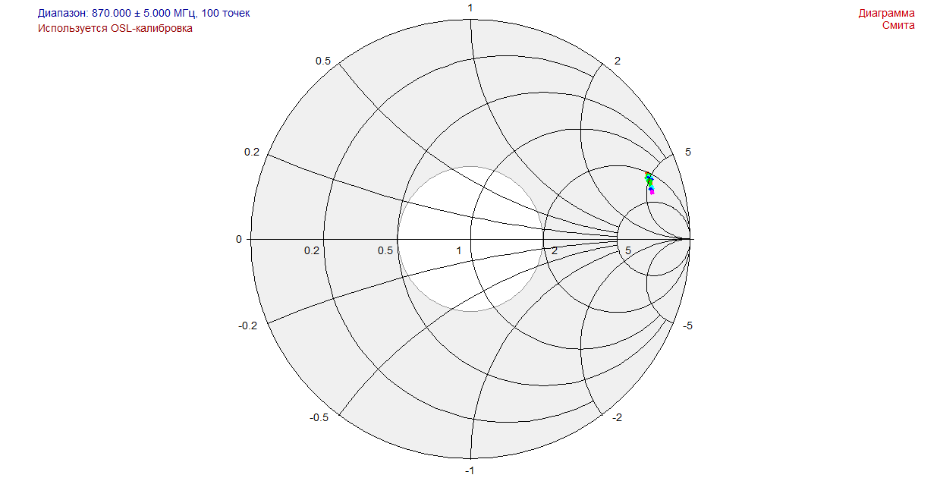

1)

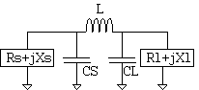

L=19.48nH (18 mounted)

CS=6.576pF (6.8 mounted)

CL=2.72pF (2.7)

Result: 17.5-j10

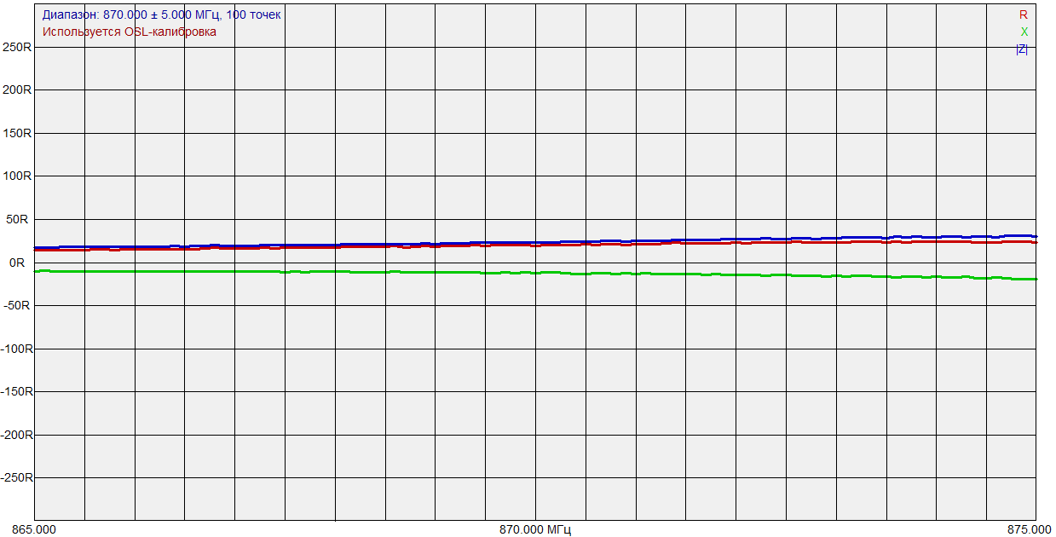

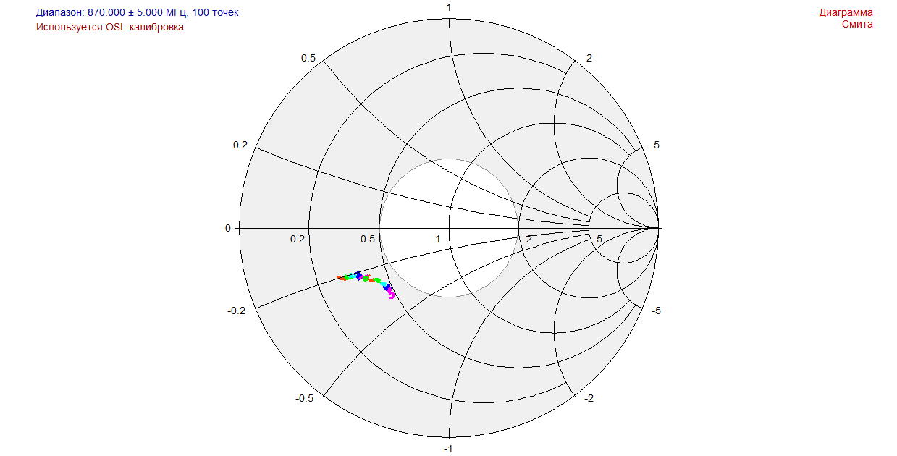

2)

L = 15nH

CS = 6.8

CL = 2.7

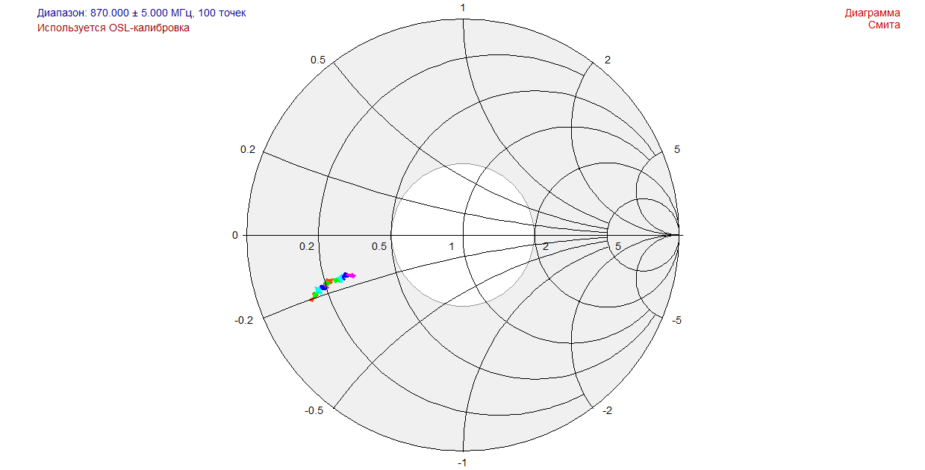

3)

L = 15nH

CS = 6.8

CL = 3.3

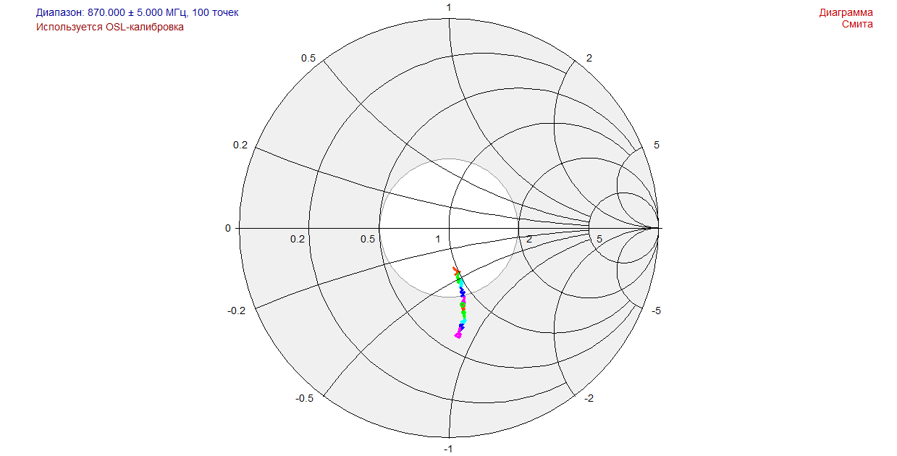

47.1-j29

4)

L = 18nH

CS = 6.8

CL = 3.3

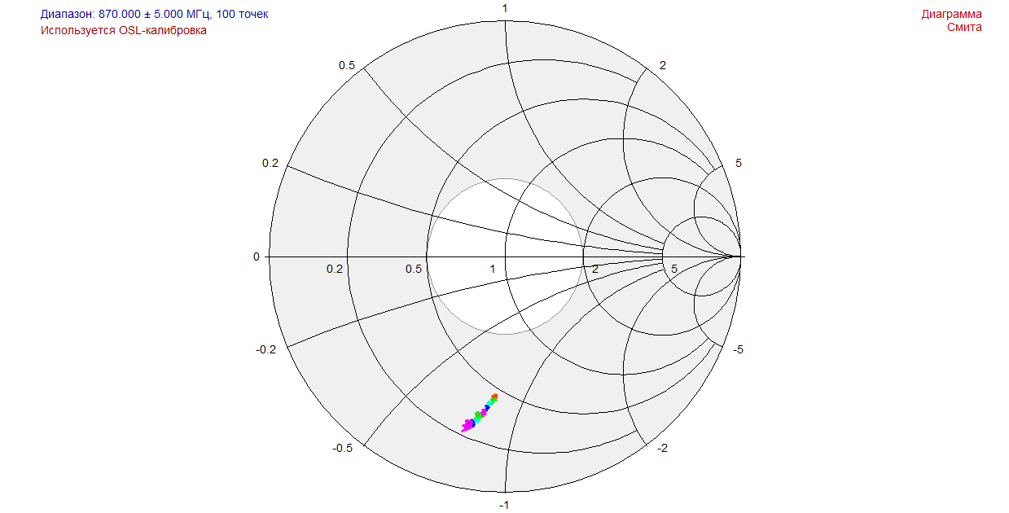

18.9-j40

5)

L = 12nH

CS = 6.8

CL = 3.3

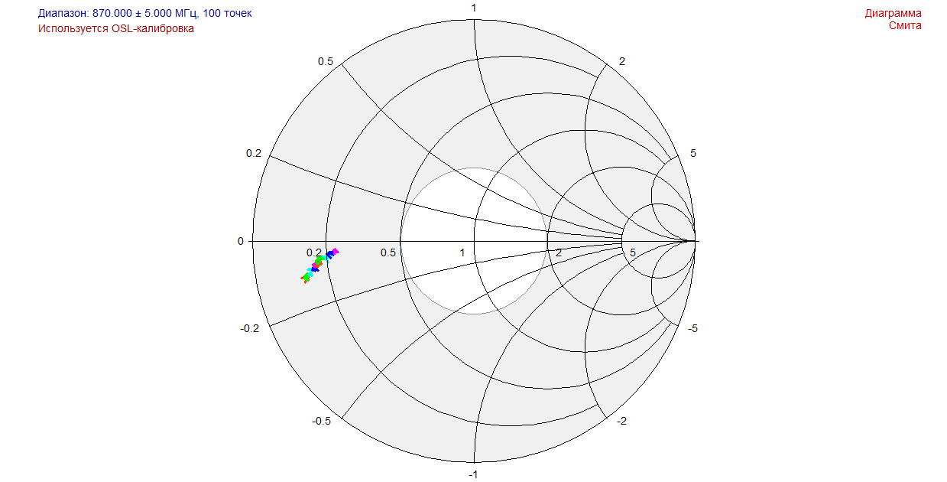

6)

L = 33nH

CS = 0

CL = 0

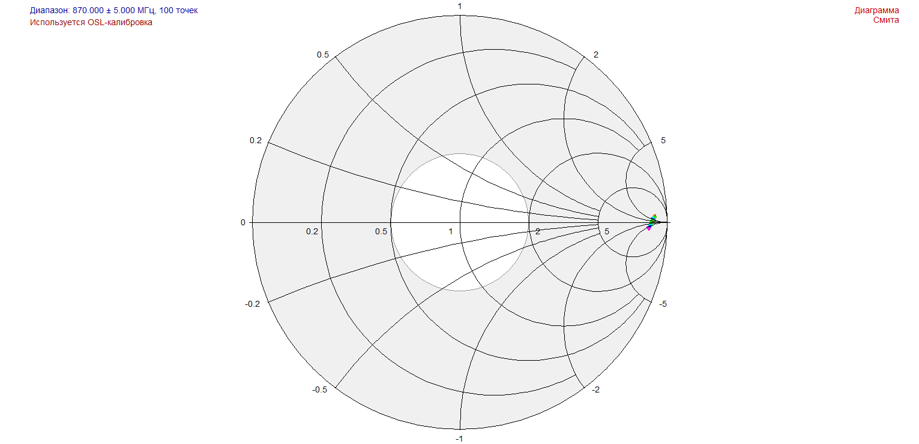

7)

L = 33nH

CS = 0

CL = 1.5

